Understanding the Signs in Your Natal Chart
Find more worksheets and resources at jezlayman.com/astrology
♈ Aries / ♉ Taurus / ♊ Gemini / ♋ Cancer / ♌ Leo / ♍ Virgo / ♎ Libra
♏ Scorpio / ♐ Sagittarius / ♑ Capricorn / ♒ Aquarius / ♓ Pisces
Fill in the signs for each planet in your chart, then use the image below to find the element, modality, and polarity associated with each sign. For example, if your sun is in Aries, the element would be Fire, the modality Cardinal, and the polarity positive.
Planet | Sign | Element | Modality | Polarity
Sun ☉ |  |  |  | Pos Neg
Moon ☽ |  |  |  | Pos Neg
Rising |  |  |  | Pos Neg
Mercury ☿ |  |  |  | Pos Neg
Venus ♀ |  |  |  | Pos Neg
Mars ♂ |  |  |  | Pos Neg
Jupiter ♃ |  |  |  | Pos Neg
Saturn ♄ |  |  |  | Pos Neg
Uranus ♅ |  |  |  | Pos Neg
Neptune ♆ |  |  |  | Pos Neg
Pluto ♇ |  |  |  | Pos Neg

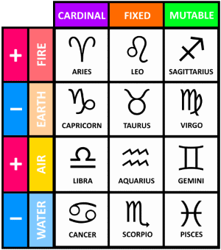
Next, count up the number of planets for each element, modality, and polarity below.
Fire:
Earth:
Air:
Water:

Cardinal:
Fixed:
Mutable:

Positive:
Negative:

